# SANJALIKA WATERPARK SLIDE’S DESCRIPTION WITH MORE FEATURES



Figure sanjalika waterpark

Sanjalika Water Park is definitely an ultimate and out of the world source of entertainment. Decorated by mermaids, other statues, the Sanjalika Water park has largest cave and swimming pool area of modern technology a kind of place for thrills and fun. At Sanjalika Water park there is lot of water rides which are very exciting and thrilling.

In this document, you are gonna learn about more features of the slides with their information.

SPIRALLO SLIDE

Water parks are amusement parks that consist of lots of slides, playgrounds, swimming pools and lots of other areas which are full of water but are covered with various roundabouts. Water parks are mostly the favorite place to visit for every child and a lot of families during the summer visit various water parks as well. There are a lot of famous water parks around the world, and here a few of those water parks would be discussed where one can enjoy a **water park picnic** with his family.

FEATURES OF THE SPIRALLO SLIDE

Spiral slide is the most classic water slide on the market at present. It can share a platform with other water slides. Haisan can customize spiral slide according to land of customer.

MORE FEATURES

|  |  |
| --- | --- |
| **Floor space** | 50m×35m |
| A slide | |
| **Capacity** | 1person/lane |
| **Platform height** | 11m |
| **Length** | 80m |
| **Width** | 1m |
| **Tube** | Yes |
| **Production Method** | Spray up |
| B slide | |
| **Capacity** | 1person/lane |
| **Platform height** | 11m |
| **Length** | 82m |
| **Width** | 0.8m |
| **Tube** | No |
| **Production Method** | Spray up |
| C slide | |
| **Capacity** | 1person/lane |
| **Platform height** | 14m |
| **Length** | 110m |
| **Width** | 1.3m |
| **Tube** | No |
| **Production Method** | Spray up |
| D slide | |
| **Capacity** | 1person/lane |
| **Platform height** | 11m |
| **Length** | 85m |
| **Width** | 0.8m |
| **Tube** | Yes |
| **Production Method** | RTM |

SPIRALLO SLIDE IMAGES

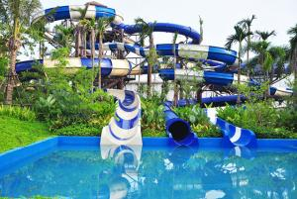

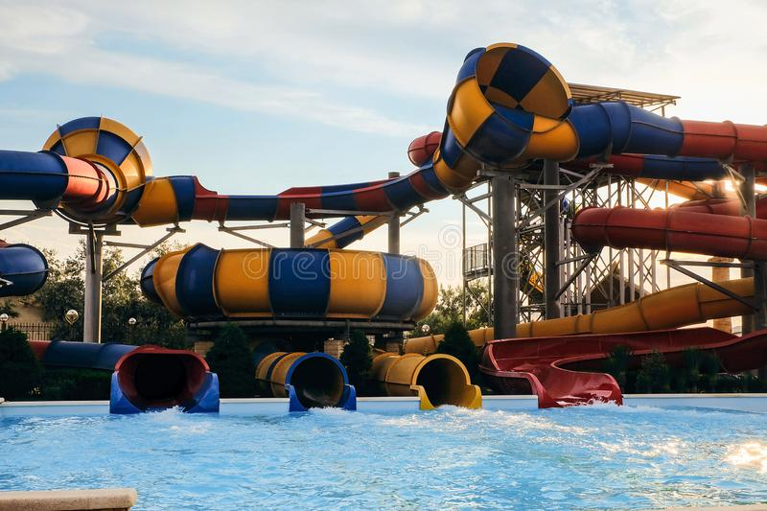

And many more images, customer feedback on such slides have always been good and keeps getting better.

Thank you!